**OOP CONCEPTS**

**1.CLASS AND OBJECT**

A class is a blueprint for creating objects and it defines the properties (attributes) and behaviour (methods) of an object.

An object is an instance of a class.

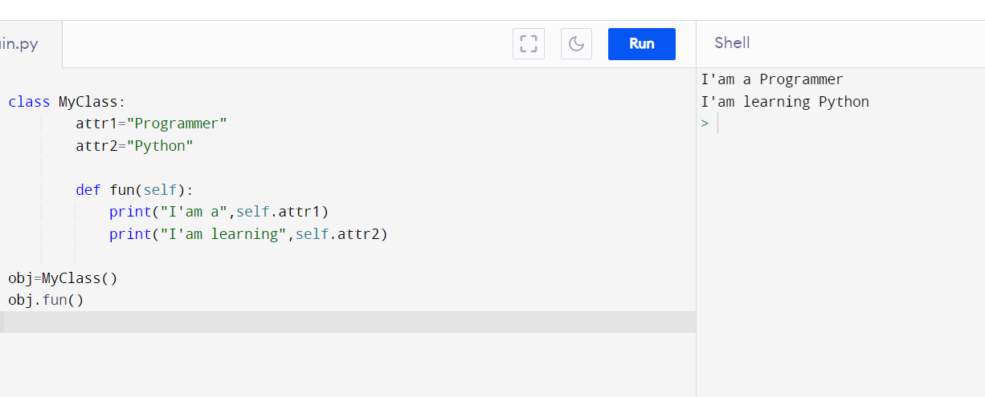

**2.INHERITANCE**

Inheritance is a mechanism by which one class inherits the properties and behaviour of another class.Class that is being inherited is called superclass and the class that inherits is called subclass.

TYPES OF INHERITANCE

1. Single Inheritance : It enables a derived class to inherit properties from a single parent class.

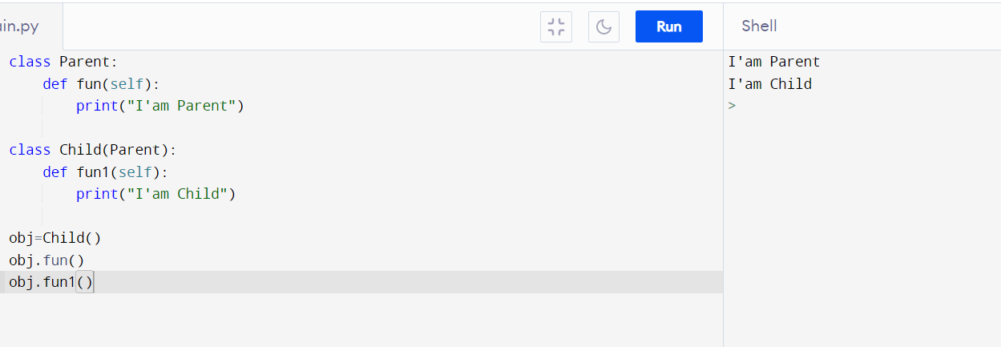

1. Multiple Inheritance : When a class can be derived from more than one base class,it is called multiple inheritance. In this,all features of base classes are inherited into derived class.

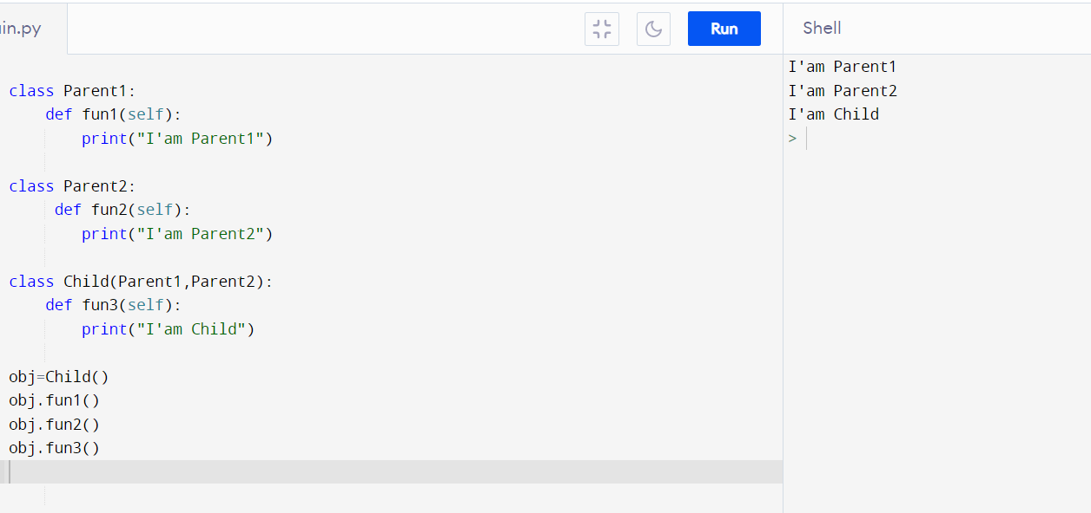

1. Multilevel Inheritance : The inheritance of a derived class from another derived class is called multilevel inheritance.

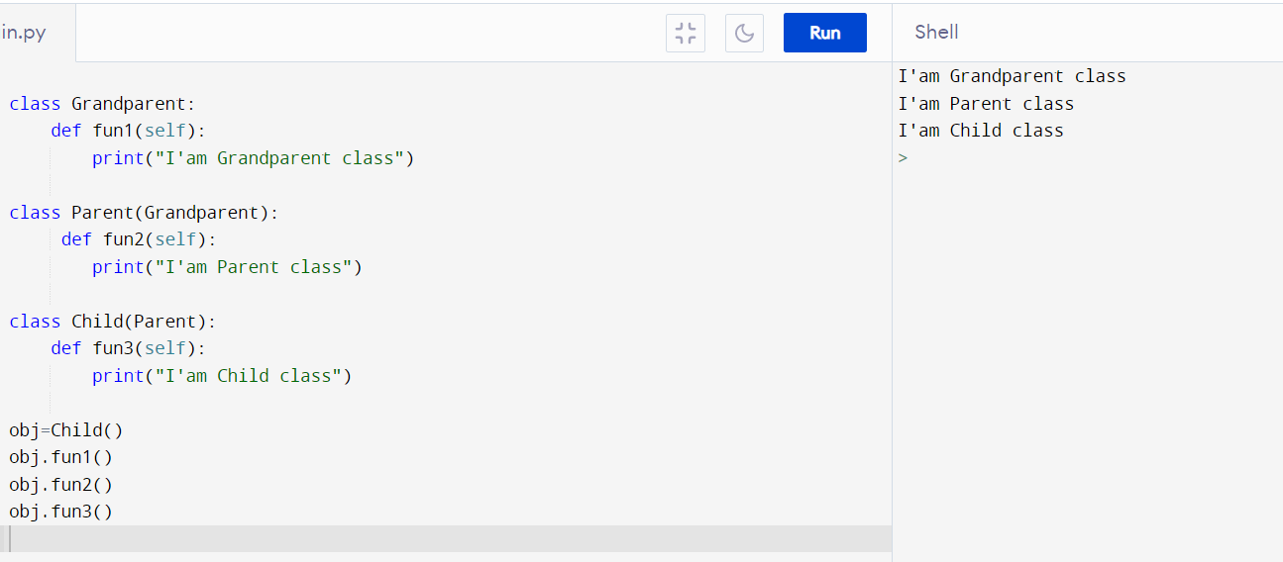

1. Hierarchical Inheritance : When more than one derived class are created from a single base class, it is called hierarchical inheritance.

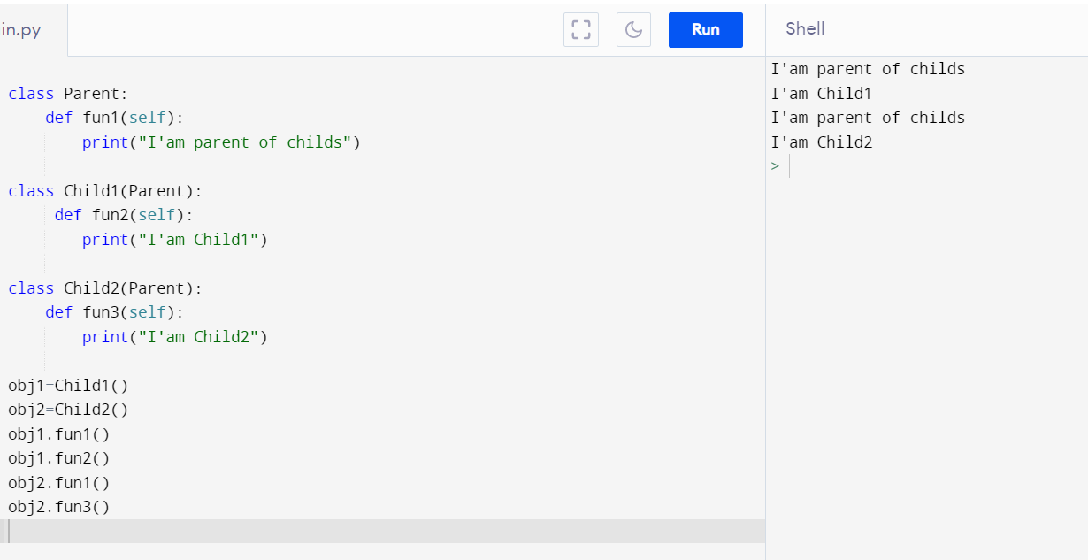

1. Hybrid Inheritance : Inheritance consisting of multiple types of inheritance is called hybrid inheritance.

